CONNECTION INFORMATION

The transmitter will transmit under 2 conditions
- When the power is applied.
- With the power permanently applied, simply open circuit the N/C to negative loop.
In both circumstances the transmitter will show the transmission by the transmission LED.
The transmissions will time out after a few seconds.

Therefore to connect the HPATX to a N/O contact simply insert the N/O contact in series with the supply or connect across the siren if this is the signal to be sent.
For the N/C contact, simply connect the mag contact or passive IR N/C loop to the N/C terminal of the HPATX and negative. With the supply connected, as soon as the loop is opened, there will be a transmission. This will be indicated by the transmit LED.

NOTES ON INSTALLATION

When fitting the HPATX, keep the aerial away from metal objects such as metal poles or steel sheeting. These will absorb a portion of the signal and thereby reducing the range.

4
High Powered Alarm TX
Item code
HPATX

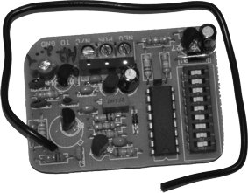

INDEX

Specifications P2

Connection layout information P3

Connection information P4

SPECIFICATIONS

Input voltage 15 V DC 11V AC

Input current 30mA

Frequency of Operation 403, 55 MHz or
433, 92 MHz
Others available on
request

Output power 6mw ERP

Coding format 9 Way trinary

Maximum number of codes 19683

Type of contacts N/O and N/C

2
CONNECTION LAYOUT INFORMATION

Negative

Positive

N/C Trigger

3

