- Press the button that you want to program into the receiver, hold it at arm’s length away from the receiver and keep it pressed.
- Press the program button on the receiver with your other hand and keep it pressed.
- The relay LED will flash every 2 seconds. When it has pulsed as many times as the location you have decided to use, release the program button.
- After about 2 seconds the relay LED will go out which confirms that the code has been accepted into the receiver at that memory location.
- You may now release the remote control button. The button is now loaded into the chosen location.
- Repeat steps 1 to 9 with all the other remote controls.
- Notes: If the LED remains on after releasing the program button, then the transmitter was not stored. Simply remove power and repeat steps 1 to 9.
- You must use a different location for each differently coded remote control otherwise you will overwrite the previous remote code in that particular location.
- If 2 transmitters are stored in the same location, the first TX will be overwritten by the second TX. Only 1 remote code can be stored in a memory location. A useful method to replace a lost remote control. See 12. above.
- To replay the location of a remote, press the remote and then the program button together, then release both. The LED will flash back the location of that remote button.
- To erase all memory, power down and with the program button pressed, power up again. After 1 second all memory will be erased and the program button can be released.
2 CHANNEL MULTITEK RECEIVER
2CMR
2 Channel Multitek Receiver
(For normal internal use)
and
2CEMR
2 Channel External Multitek Receiver
(Weather proof version for outdoor use)
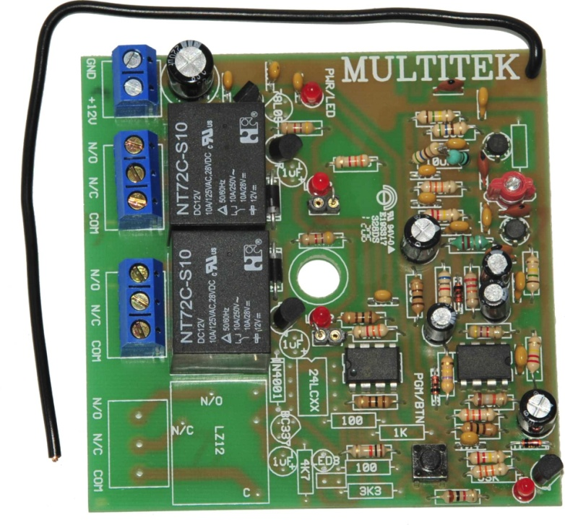

INDEX

SPECIFICATIONS P2

NOTES ON CONNECTION AND USE P2

CONNECTION INFORMATION P3

MULTITEK RX PROGRAMING P3 & P4

SPECIFICATIONS

Input operating voltage | 10 V dc to 35 V dc (pulsed mode)  10 V dc to 15 V dc (latched mode)
Contact current rating | 5Amp at 220V ac
Frequency of operation | Available in 403,55Mhz or 433,92Mhz
Sensitivity | 1uV @ 1:100 BER
Max no. of memory locations | 7 per relay
Coding formats | Binary, Trinary, French & Keeloq code hopping

NOTES ON CONNECTION AND USE

The relay contacts are potential free.
The link on board provides the option of having the relay in pulse or latch mode. Link out is for pulse mode and link in for latch mode.
.

2
CONNECTION INFORMATION

MULTITEK RX (2CMR & 2CEMR) PROGRAMMING
- Code up the transmitter by changing any of the code switches (not needed if using code hopping).
- Power up the receiver.
- Press the program button until desired relay LED lights up and relay pulls in. Release the program button. The receiver is now set ready for programming on that particular relay.
- Decide on which memory locations you want to store the remote into. You have 7 locations per relay to choose from. Remember every differently coded remote control must have its own memory location. 3

