12
999 DIGITAL RECEIVER
INSTRUCTION
MANUAL
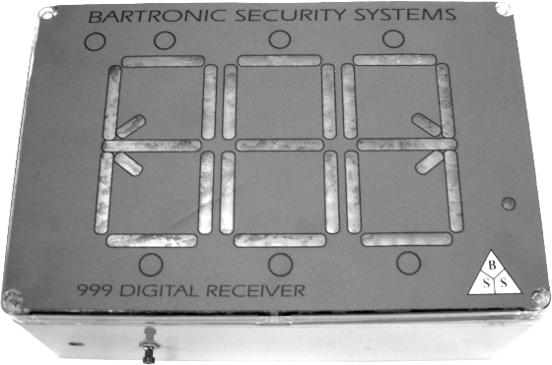

INDEX

Index 2
Packing list 2
Specifications 3
Connector block wiring 4
Connection block diagram (fig 2) 5
Front panel layout 6
Front panel controls 7
Functions and features 7
Programming procedure 8
Removing remote controls from memory 8

PACKING LIST

1 x 999Digital receiver (internal to the housing is the 12 volt, 7 amp hr battery & control board)

1 x 12 Volt charger

1 x 16 V AC Plug in transformer

1 x 12 Volt 7 Amp hour battery

1 x Instruction manual

2

11

10

SPECIFICATIONS

Display
Max number on display 999
Number of memory locations 8000 (8 per number)
Formats received Trinary, Binary, Code hopping, French
Activation memory 20 signals in sequence
order received.

Electrical Rating
Voltage 13 Volts DC
Relay voltage 50 Volts
Relay current 2 Amps
Standby current 40mA (average)

Onboard Receiver

Frequency 403,55Mhz or 433,92Mhz
(other frequencies possible)
Sensitivity 1uV @ 1:100 BER
Coding Formats 12 Bit Binary
9 Bit Trinary
French rolling code
Code Hopping
3
CONNECTOR BLOCK WIRING

Negative (Battery -) This goes to the Negative of the battery.

Positive +12 Volts This is the +12 volts from the battery.

Positive +12V for ext RX This is a +12 V if using an external RX.

Data from ext RX This is data from an ext RX.

Ground for RX Ground for the external RX.

Reset This is connected to the reset switch.

Reset This is connected to the reset switch.

Relay N/C This is the Normally Closed contact of the onboard relay.

Relay Common This is Common contact of the onboard relay.

Relay N/O This is the Normally Open contact of the onboard relay.

Onboard Buzzer link Removing this link disables the onboard buzzer.

Onboard receiver link This link must be removed when connecting an external rx to the 999 Digital rx.
4
SINGLE MEMORY LOCATION
Each number on the display has 8 memory locations so that up to 8 differently coded remote controls can be used (required when using code hopping remote controls).
1. If the exact memory location is known of the remote control to be removed, then simply over write that memory location with another remote control.
2. Alternatively if the exact memory location is not known then all the remote controls for that displayed number will have to be reloaded into memory thereby overwriting the unwanted codes.

9
PROGRAMING PROCEDURE
- Press the programming button until 0 0 0 shows up on the display.
- Using the UP and DOWN buttons set up the number that is to be displayed when the remote control is pressed.
- Decide which memory location within the displayed number that the remote code is to be inserted. There are 8 locations per displayed number to chose from.
- Press the remote control button and keep it pressed while pressing the program button. The display will flash as well as the beeper sounding when the display flashes.
- Count the flashes until the desired memory location is reached. Release the program button at this memory location.
- When the display reverts to - - - then the procedure is complete.
- Release the remote control button.
- Press the reset button (found under the unit.)

REMOVING REMOTE CONTROLS FROM MEMORY
There are 2 methods of removing remote control codes from the 999 Digital receiver.

MASTER CLEAR (ALL CLEAR TO DEFAULT)
Remove the power from the board. Press the program button and keep it pressed while re-applying the power to the board. When the display starts to test each row of LED's you can release the program button. At the end of the self-test process the memory will be cleared. WARNING ALL MEMORY WILL BE CLEARED IN THIS MANOR.
8
CONNECTOR BLOCK DIAGRAM (fig2)

5
FRONT PANEL LAYOUT

6
FRONT PANEL CONTROLS
PROGRAM BUTTON
This button is found on the inside of the box. The 4 corner screws on the lid must be removed to gain access to this programming switch. When pressed this will put the unit into program mode so the remote codes can be inserted into the memory.

UP BUTTON
These buttons which are above each display will increment the display number shown below it.

DOWN BUTTON
These buttons which are below each display will decrement the display number shown above it.

RESET BUTTON
This button found under the display box and resets the display.

SIGNAL LED
This LED will light up when a remote control signal is received when using the onboard receiver.

FUNCTIONS AND FEATURES
BUZZER
Removing the link marked ONBOARD BUZZER as shown in fig 2 will disable the buzzer and allow for quiet operation.

EXTERNAL RECEIVER
This is used when longer range is required. In this situation an external receiver is mounted outside the building away from surrounding walls and interference. The data and power of this external receiver is connected to the 999Digital receiver. In default mode the 999Digital receiver is set to using the built-in onboard receiver. To set the unit into external mode, remove the link marked ONBOARD RECEIVER. Then connect the external receiver to the connector blocks as shown in fig 2 7

