- The relay LED will flash every 2 seconds. When it has pulsed as many times as the location you have chosen, release the program button.
- After 1 second the relay LED will go out which confirms to you that the code has been accepted into the receiver at that memory location.
- You may now release the remote control button.
- The button is now loaded into the chosen location.
- Repeat steps 1 to 9 with all the other remote controls. Note you must use a different location for each differently coded remote control otherwise you will overwrite the previous remote code in that particular location.
- Note: - If the LED remains on after releasing the program button, then the transmitter was not stored. Simply remove power and repeat steps 1 to 9.
- If 2 transmitters are stored in the same location the first TX will be overwritten by the second TX. Only 1 remote code can be stored in a memory location. A useful method to replace a lost remote control. See 11. above.
- There is a link on the board which is used for placing the receiver into latch or pulse mode. Link in = latch mode. Link out = pulse mode.
- To replay the location of a remote, press the remote and then the program button together. The LED will flash the location of the remote button.
- To delete the entire memory, remove the power, press the program button and re-apply power while still pressing the program button. The entire memory is now cleared.
4

1 CHANNEL MULTITEK RECEIVER
1CMR
1 Channel Multitek Receiver
(For normal internal use)

and

1CEMR
1 Channel External Multitek Receiver
(Weather proof version for outdoor use)
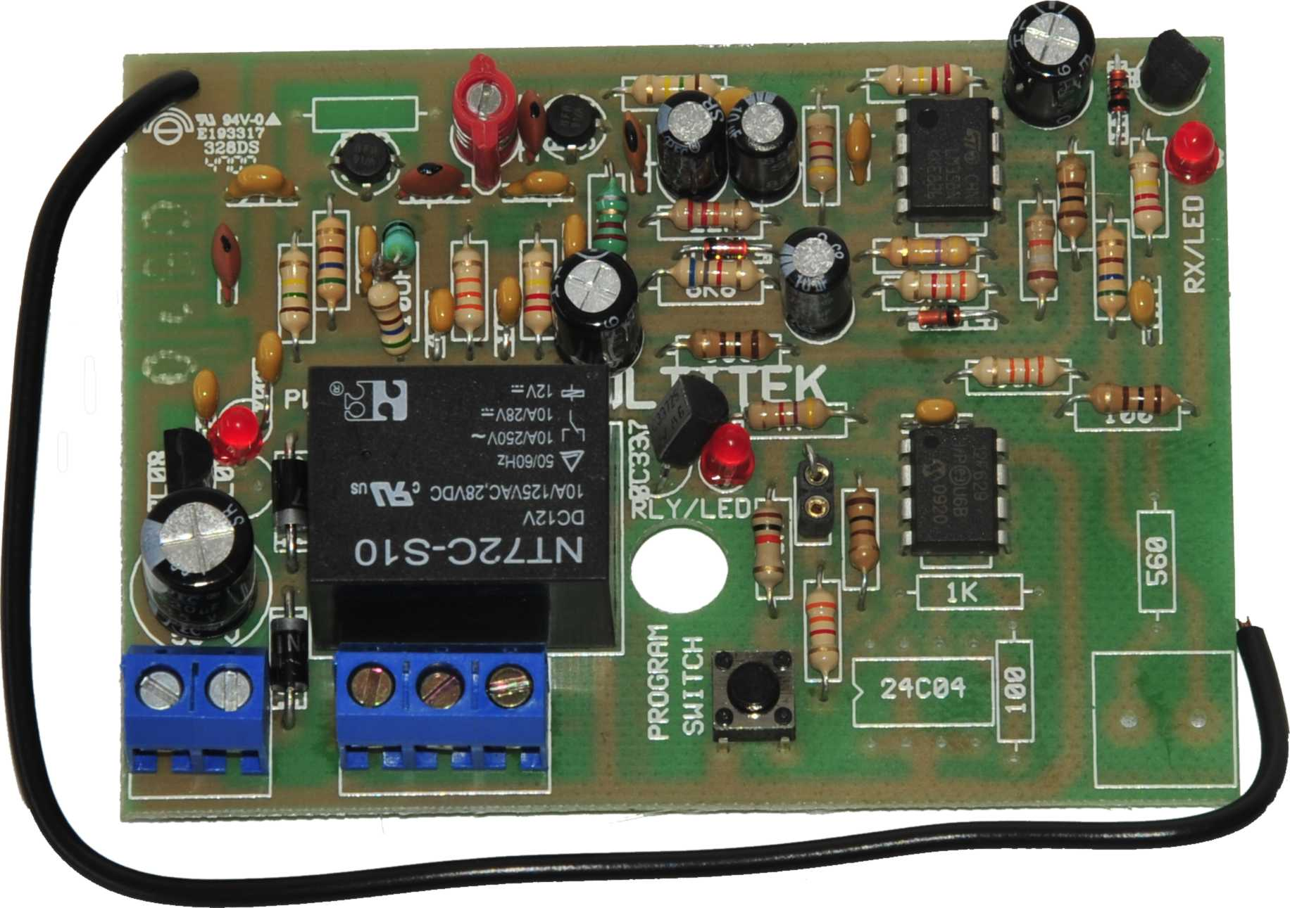

INDEX

SPECIFICATIONS P2

NOTES ON CONNECTION AND USE P2

CONNECTION INFORMATION P3

MULTITEK RX PROGRAMING P3

SPECIFICATIONS

Input operating voltage | 10 V dc to 35 V dc (pulsed mode)  10 V dc to 15 V dc (latched mode)
Contact current rating | 5Amp at 220V ac
Frequency of operation | Available in 403,55Mhz or 433,92Mhz
Sensitivity | 1uV @ 1:100 BER
Max no. of memory locations | 21
Coding formats | Binary, Trinary, French & Keeloq code hopping

NOTES ON CONNECTION AND USE

The relay contacts are potential free.
The link on board provides the option of having the relay in pulse or latch mode. Link out is for pulse mode and link in for latch mode.
The Data out terminal is only found in the External Multitek receivers only and provides unprocessed data for other BSS receivers when long range is needed.

2
CONNECTION INFORMATION

MULTITEK RX (1CMR & 1CEMR) PROGRAMMING

- Code up the transmitter by changing any of the code switches. (Not needed with Code hopping remotes.)
- Power up the receiver.
- Press the program button until relay LED lights and relay pulls in. Receiver is now set ready for programming.
- Decide on which memory locations you want to store the remote into. You have 21 locations to choose from.
- Press the remote button that you want to program into the receiver, at arm’s length away from the receiver and keep it pressed.
- Press the program button on the receiver with your other hand and keep it pressed.

3

