- The relay LED will flash every 2 seconds. When it has pulsed as many times as the location you have chosen, release the program button.
- After 1 or 2 seconds the relay LED will go out which confirms that the code has been accepted into the receiver at that memory location.
- You may now release the remote control button.
- You now have the button loaded into the chosen location.
- Repeat steps 1 to 9 with all the other remote controls. Note you must use a different location for each differently coded remote control otherwise you will overwrite the previous remote code in that particular location.
- Note: - If the led remains on after releasing the program button, then the transmitter was not stored. Simply remove power and repeat steps 1 to 9.
- If 2 transmitters are stored in the same location the first TX will be overwritten by the second TX.
- There is a link on the board which is used for placing the receiver into latch or pulse mode. Link in = latch mode. Link out = pulse mode.
- To bring in a timer feature press the program button as in step 3 above but keep pressing the program button. After 5 seconds the relay led will start to pulse. Every pulse will produce a 1-minute time delay. Release the program button when the required time is reached.
- If the program button is pressed at the same time as a preloaded remote control, then the LED will flash the location of that remote control.

4
1 CHANNEL MAINS MULTITEK RECEIVER

1CMMR
1 Channel Mains Multitek Receiver
(for normal internal use)
and
1CEMMR
1 Channel External Mains Multitek Receiver
(Weather proof version for outdoor use)
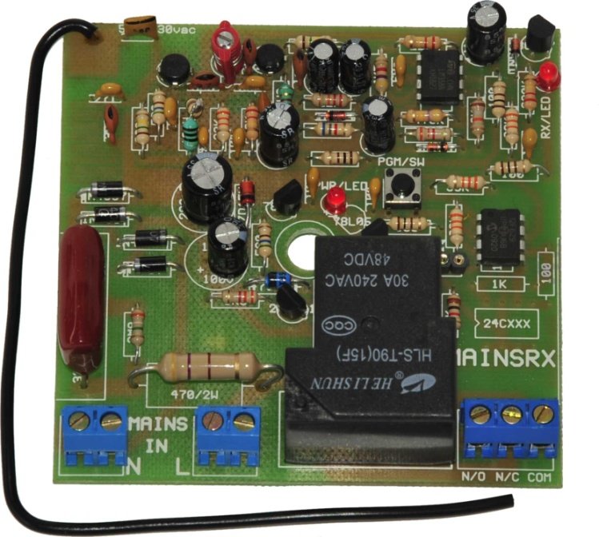

INDEX

SPECIFICATIONS P2

NOTES ON CONNECTION P2

CONNECTION INFORMATION P3

CODING INSTRUCTIONS P3 & P4

SPECIFICATIONS

Input operating voltage | 100 V ac to 240V ac
Contact current rating | 15Amp at 220V ac
Frequency of operation | Available in 403,55Mhz or 433,92Mhz
Sensitivity | 1uV @ 1:100 BER
Max no. of memory locations | 21
Coding formats | Binary, Trinary, French & Keeloq code hopping

NOTES ON CONNECTION
The neutral terminals are bridged underneath the connector block so to provide a neutral in from supply and a neutral out to the load. The same applies to the live terminals.
The relay contacts are potential free so simply connect from the live terminal to one of the relay contacts e.g. common. Then connect the load to either the N/C or N/O (depending on power up mode desired).

2

CONNECTION INFORMATION

MAINS RX (1CMMR & 1CEMMR) PROGRAMMING

- Code up the transmitter by changing any of the code switches.
- Power up the receiver. Be careful 220 volts in the circuitry
- Press the program button until relay LED lights and relay pulls in. Receiver is now set ready for programming.
- Decide on which memory locations you want to store the remote into. You have 21 locations to choose from.
- Press the button that you want to program into the receiver, at arm’s length away from the receiver and keep it pressed.
- Press the program button on the receiver with your other hand and keep it pressed.
3

